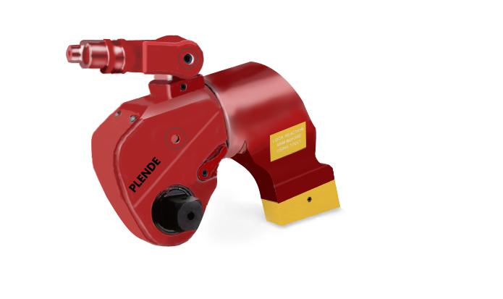

Hydraulic Wrench
--The maximum working pressure 70Mpa, Torquet Accuracy ±3%
--10 models from 112 to 72000Nm are the most complete and most
popular of bolt coverage of similar products.
--360*180 degree Swivel-Hose-free operation, no limit to use.
--Drive connection sleeve high strength work, bolt adaptation range
--Anti-Lock Switch, 360 degree Reaction Arm-Easy to working in any position
--Body housing-Aluminum-Titanium alloy, high strength, high toughness.
--“Drop Hole” will protect over pressure operating.

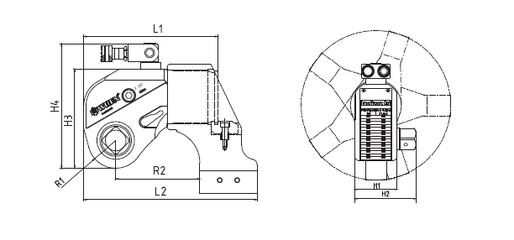

A0201Series Hydraulic Torque Wrench Selection Table

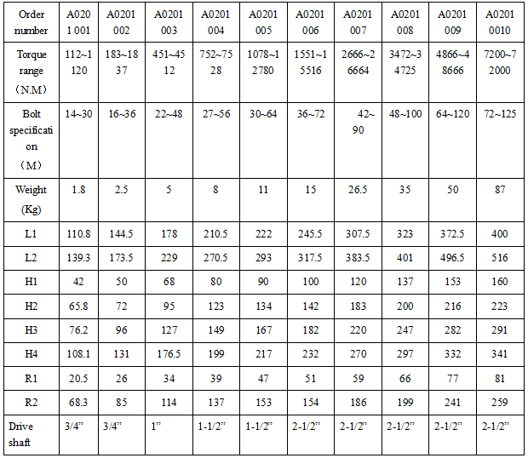

This series of professional hydraulic torque wrench is the main force which the PLENDE company launch into the international market. The aluminum titanium alloy aeronautical materials wrench is in light weight, high strength, this is mean that this series of hydraulic torque wrench contains 10 standard models from 112Nm to 72000Nm, besides, the vast usage specifications and high bolt coverage reflects that the firm foundation and professionalism of PLENDE in working on international bolt service. PLENDE also provides global after-sales service, and owns integrated matching supply capacity which is through the German Rhine TüV certification.

Hexagon Cassette Wrenches Lightweight, Low profile & Slim Nose Radius

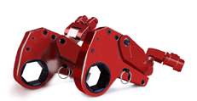
--The maximum working pressure 70Mpa, Torquet Accuracy ±3%
--5 models from 232 to 44593Nm
--360*180 or 360*360 degree Swivel-Hose-free operation, no limit to use.
--Direct effects on nut, torque more accurate, more light
--One-piece extension design, arm is longer, improve reliability
--Body housing-Aluminum-Titanium alloy, high strength, high toughness.
--“Drop Hole” will protect over pressure operating.
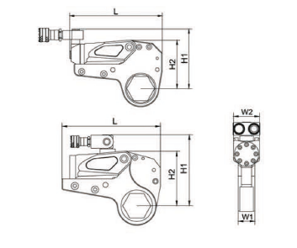
A0202Series Hydraulic Torque Wrench Selection Table
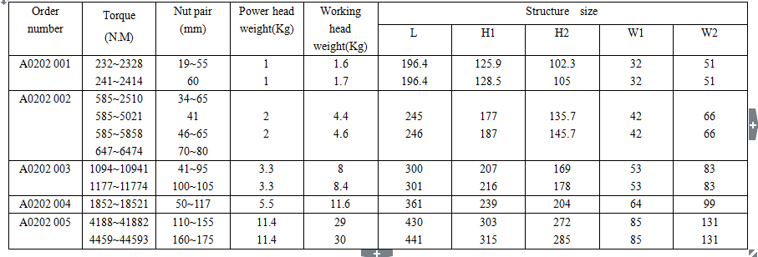
This series of professional hydraulic torque wrench is the main force which the PLENDE company launch into the international market.Compared with the hydraulic torque wrench, Hollow type hydraulic torque wrench directly use for nuts with thin volume, and is very suitable for the operation in a narrow space. This series wrench can adapt to different working condition by adjusting the head of machine, and fitting reduction sleeve, this series cover the bolt from S19 to S175. PLENDE also provides global afte-sales service, and owns integrated matching supply capacity which is through the German Rhine TüV certification.

Hydraulic Electric/Torque Wench Pump
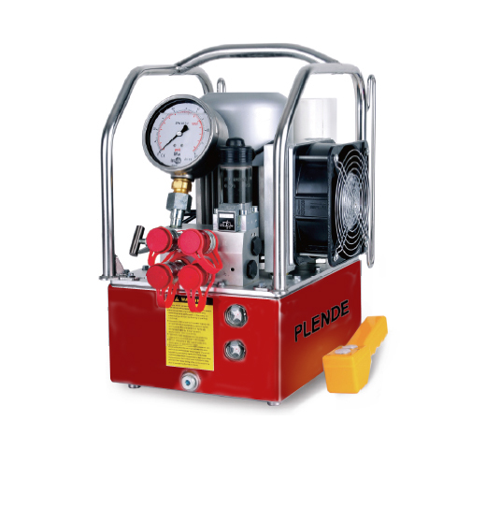
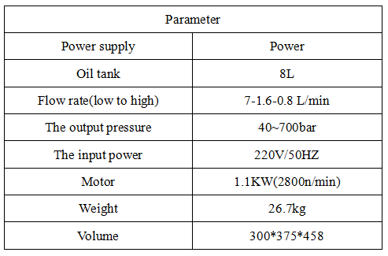
--High Efficiency, Tri-speed automatic.
--That can synchronize work for 2 hydraulic wrench.
(Also can work for 4 hydraulic wrench in other configuration)
--Body housing-Aluminum-Titanium alloy， portable。
--φ100 high precision pressure gauge, ensure high precision torque wrench
--Within the scope of the 40 ~ 700 bar free adjustment of output pressure
--equipped with radiator, can continuous working 24 hours a day
--according to the customer request provide different voltage/frequency of motor
Hydraulic Air/Torque Wench Pump
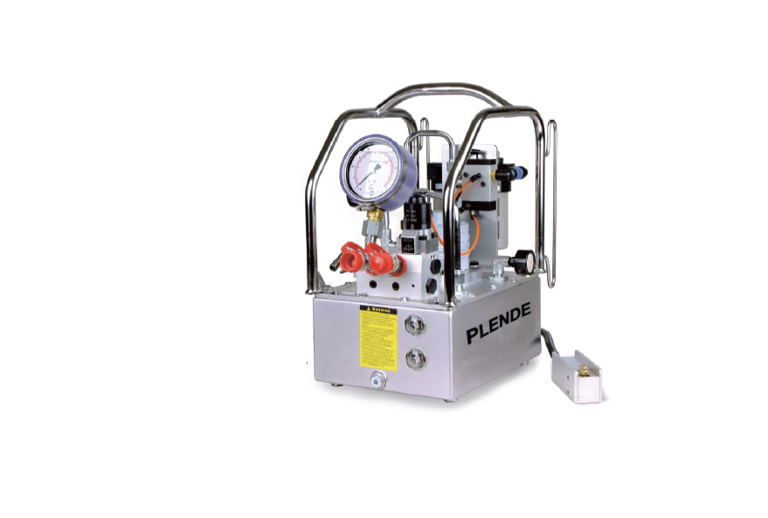

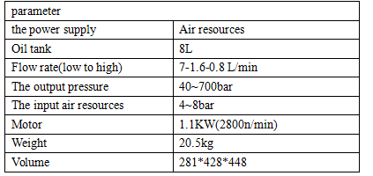

--In the air (4 to 8 bar) as the main source of power under the conditions of use
--Automatic level 3 pump, but under the condition of full load output
--That can synchronize work for 2 hydraulic wrench.
(Also can work for 4 hydraulic wrench in other configuration)
--Body housing-Aluminum-Titanium alloy, total weight is only 20.5kg.
--φ100 high precision pressure gauge, ensure high precision torque wrench
--Within the scope of the 40 ~ 700 bar free adjustment of output pressure
--Equipped with manual switching efficient cooling system, adapted to extreme environment

Hydraulic Nut Splitters
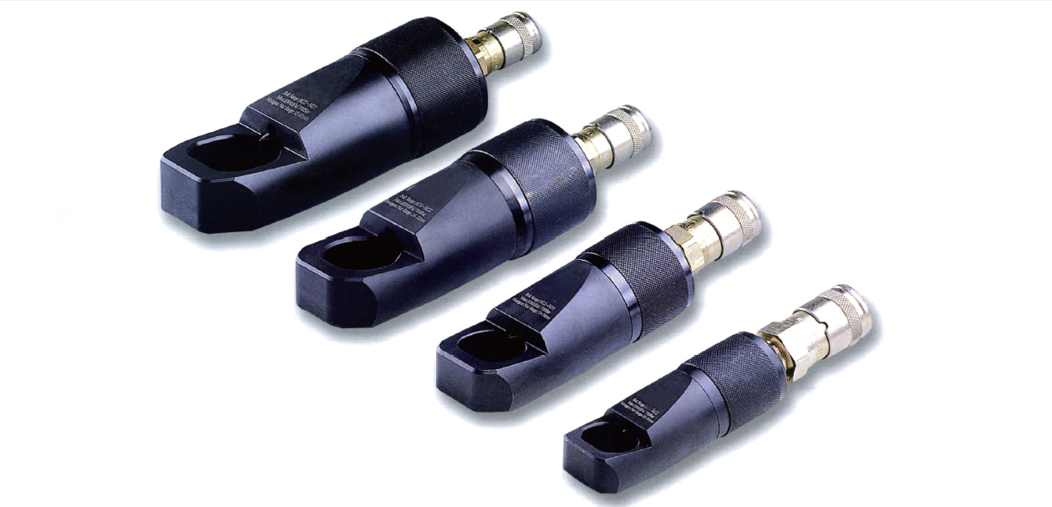

Capacity：5-90Ton
Bolt Range：M6-M48
The maximum working pressure：700bar
--compact and ergonomic design, easy to use
--Unique angled head allows flush access
--Sing-acting, spring return cylinder
--Heavy-duty chisels can be reground
--Use on any output pressure of 700 bar
single-acting hydraulic pump station
--Applications include servicing trucks, piping industry, tank cleaning,
petrochemical, steel construction and mining.
Hydraulic nut splitters selection table
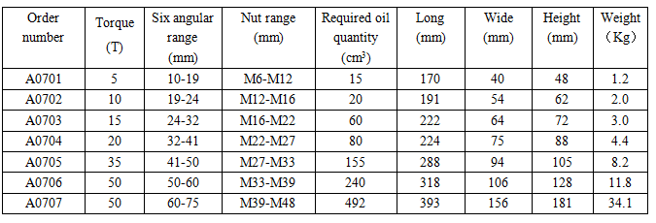
Nut shall not exceed HRC hardness - 44 delicate for stainless sateel romy and square nut.

